**Lab06**

**Question 01:**

public class Main {

public static void main(String[] args) {

int[][] arr={ {4,3,24,9},{5,7,6,8} };

for(int k=0;k< arr.length;k++){

for (int i=0;i<arr.length;i++)

for (int j=0;j<arr[k].length-i-1;j++)

if (arr[k][j]>arr[k][j+1]){

int tem=arr[k][j];

arr[k][j]=arr[k][j+1];

arr[k][j+1]=tem;

}

}

for (int i=0;i<arr.length;i++){

for (int j=0;j<arr[i].length;j++) {

System.out.print(arr[i][j]);

System.out.print(" ");

}}

}}

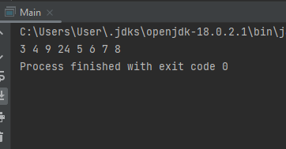

**Question 02:**

import java.util.*;

public class Main{

public void inser_sort(int arr[]){

int tem,c=0;

for (int i=1;i<arr.length;i++){

tem=arr[i];

int j=i-1;

while(j>=0&&tem<arr[j]){

arr[j+1]=arr[j];

j--;

c++; }

arr[j+1]=tem; }

System.out.print("count = " + c);

}

public static void main(String[] args) {

Main m =new Main();

Scanner sc=new Scanner(System.in);

System.out.print("size of array = ");

int s=sc.nextInt();

int arr[]=new int[s];

for(int i=0;i<s;i++){

arr[i]=sc.nextInt(); }

m.inser_sort(arr);

} }

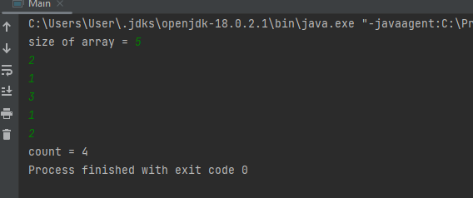

**Question 03:**

public class Main{

public void sortedase(int arr[]){

int size=arr.length;

for(int i=0;i<size;i++){

for(int j=0;j<size-i-1;j++){

if(arr[j]>arr[j+1]){

int tem=arr[j];

arr[j]=arr[j+1];

arr[j+1]=tem;

}

}

}

}

public void sorteddes(int arr[]){

int count=0;

int size=arr.length;

for(int i=0;i<size;i++){

for(int j=0;j<size-i-1;j++){

if(arr[j]<arr[j+1]){

int tem=arr[j];

arr[j]=arr[j+1];

arr[j+1]=tem;

count++;

}

}

}

}

public void display(int arr[]){

for(int i=0;i<arr.length;i++){

System.out.print(" "+arr[i]+" ");

}

System.out.println();

}

public static void main(String[] args) {

int arr[] = {7,10,11,3,6,9,2,13,0};

Main q1 = new Main();

q1.display(arr);

int arr1[] = new int[(arr.length / 2) + 1];

int arr2[] = new int[(arr.length / 2)];

int k = 0;

for (int i = 0; i < arr.length - 1; i++) {

if (i % 2 == 0) {

arr1[k] = arr[i];

k++;

}

}

q1.sorteddes(arr1);

k = 0;

for (int i = 0; i < arr.length-1; i++) {

if (i % 2 == 1) {

arr2[k] = arr[i];

k++;

}

}

q1.sortedase(arr2);

int arr3[] = new int[arr.length];

int y = 0;

for (int k1 = 0, i = 0, j = 0; k1 < arr.length && i < arr1.length || j < arr2.length; k1++) {

if (k1 % 2 == 0) {

arr3[y] = arr1[i];

i++;

}

else {

arr3[y] = arr2[j];

j++;

}

y++;

}

q1.display(arr3);

int arr4[]=new int[arr3.length/2];

int arr5[]=new int[(arr3.length/2)+1];

k=0;

for(int i=0;i<arr3.length;i++){

if(i%2==1){

arr4[k]=arr3[i];

k++;

}

}

System.out.println("even positioned elements after sorting ascending");

q1.sortedase(arr4);

q1.display(arr4);

k=0;

for(int i=0;i<arr3.length-1;i++){

if(i%2==0){

arr5[k]=arr3[i];

k++;

}

}

System.out.println("odd postioned elements after sorting descending");

q1.sorteddes(arr5);

q1.display(arr5);

} }

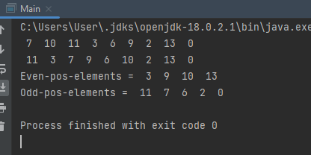

**Question 04:**

public class Main{

public static void sorting(String arr[]){

for (int i=0;i<arr.length;i++){

for (int j=0;j<arr.length;j++){

if (arr[i].compareToIgnoreCase(arr[j])<0){

String tem=arr[i];

arr[i]=arr[j];

arr[j]=tem;

}

}

}

}

public static void main(String[] args){

String arr[]= {"adam","Adrm", "Apple", "Oranges","Cats","Clothes"};

sorting(arr);

for (int i=0;i<arr.length;i++){

System.out.println("Str"+" "+(i+1)+" is " +arr[i]+ " ");

}

}

}

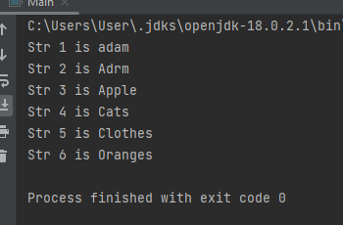

**Question 05:**

public class Main{

public static void mergesort(int[] array, int si, int ei){

if(si<ei){

int mid = (si+ei)/2;

mergesort(array,si,mid);

mergesort(array,mid+1,ei);

merge(array,si,mid,ei); }

}

public static void merge(int[] array, int si, int mid, int ei){

int i = si, j = mid+1, k = 0;

int[] arr = new int[ei-si+1];

while(i<=mid &&j <=ei){

if(array[i]<array[j]){

arr[k++]=array[i++];

}else{

arr[k++]=array[j++];

}

}

//remaining of 1st half part]

while(i<=mid){

arr[k] = array[i];

k++;

i++; }

//remaining of 2nd half part

while(j<=ei){

arr[k]=array[j];

j++;

k++; }

for (int m =si; m<arr.length ; m++){

array[m] = arr[m]; }

}

public static void main(String[] args){

int array1[] = { 12, 2, 130, 5, 6, 7 };

mergesort(array1,0, array1.length-1);

for(int i=0 ; i< array1.length ; i++){

System.out.print(array1[i]+"\t"); }

}

}

